GROUP - 3

Fuzzy Logic Controlled Traffic Signal

Submitted by,

ALEENA SARA VARGHESE (5)

ELVIS JOSEPH SHIBU (20)

HARSHA DANIEL (26)

SINDHOORA (45)

SREERAM M (47)

**INTRODUCTION**

The monitoring and control of traffic is becoming a major problem in many countries. With the ever-increasing number of vehicles on the road, the traffic monitoring authority has to find new ways or measures to overcome such a problem. The proper way of controlling traffic congestion is done by using traffic signals. Due to increase of vehicles in roads and public behaviour, fixed time-controlled traffic signal systems have not provided a solution to high traffic congestion. The aim of the traffic congestion problem is to minimize the delays in roads by effectively using the existing traffic signal systems without constructing new roads. Traffic system is more dependent on parameters such as day, time and the traffic density. The difficulty and uncertainties present in the existing traffic system can be rectified by using an intelligent traffic control system which continuously adjust the timings of traffic lights depending on the different parameters. If these parameters are not taken into consideration, the traffic control system will create delays.

**FUZZY INPUT-OUTPUT AND THEIR LINGUISTIC VARIABLES**

There are three fuzzy input variables for the proposed fuzzy logic controller

1. The first variable represents the day in which the vehicles is passing.
2. The second variable represents the time of the day
3. The third variable represents the traffic density at that particular time

The output variable that will give the extension time required for the green light on the arrival side

|  |  |  |  |  |  |  |  |
| --- | --- | --- | --- | --- | --- | --- | --- |
| **DAY** | | **TIME OF THE DAY** | | **TRAFFIC DENSITY** | | **GREEN LIGHT DURATION** | |
| **RANGE** | **VARIABLES** | **RANGE** | **VARIABLES** | **No. OF VEHICLES** | **VARIABLES** | **TIME**  **(in sec)** | **VARIABLES** |
| 0-1 | WORKING DAY | 0-5 | MORNING | 0-15 | LOW | 0-10 | SHORT |
| 1-2 | WEEKEND | 5-10 | AFTERNOON | 15-50 | MEDIUM | 10-30 | MEDIUM |
| 2-3 | PUBLIC HOLIDAY | 10-15 | EVENING | 50-100 | HIGH | 30-60 | HIGH |
| 15-20 | NIGHT |

**FUZZY IF-THEN RULES**

On the basis of 3 input variables nearly 27 fuzzy rules are framed to obtain the following output and given in table below:

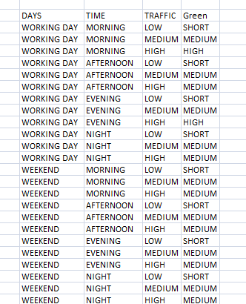

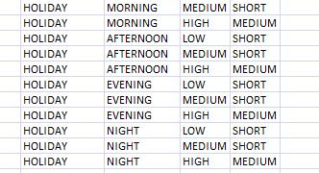

Fuzzy logic tool box in Mat lab is used to implement the proposed fuzzy logic control and fuzzy rule set. Using the graphical user interface (GUI) the membership function of input and output variables are designed as follows:

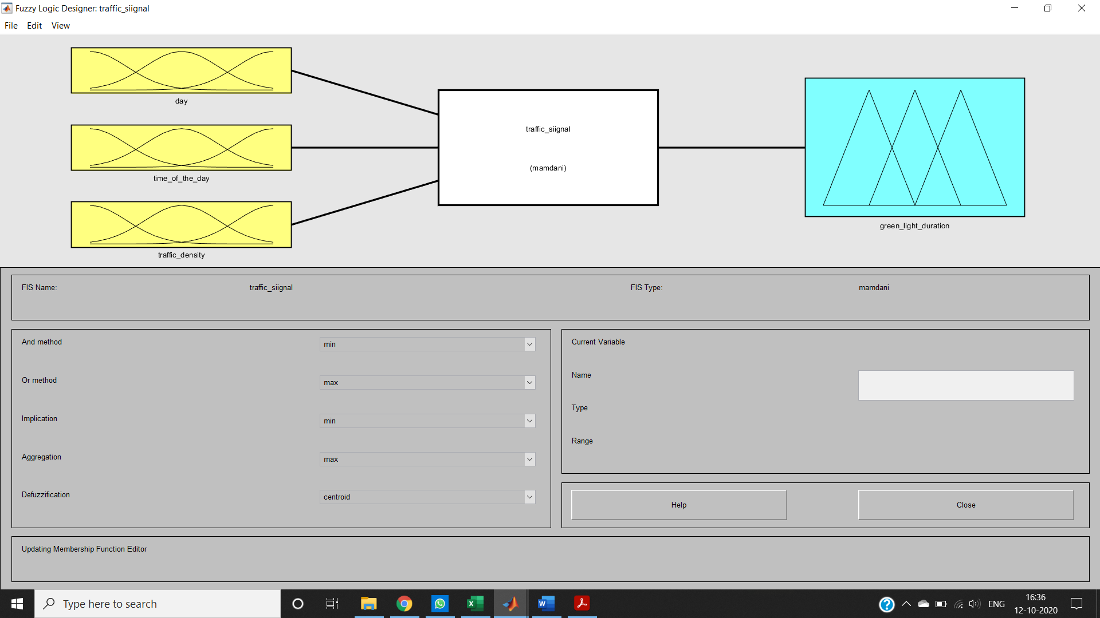

Figure 1: Input and Output Variables

The figure 2 shows the membership function for the input variable day. The membership function for day are working day = 0 to 1, weekend = 1 to 2 and public holiday= 2 to 3.

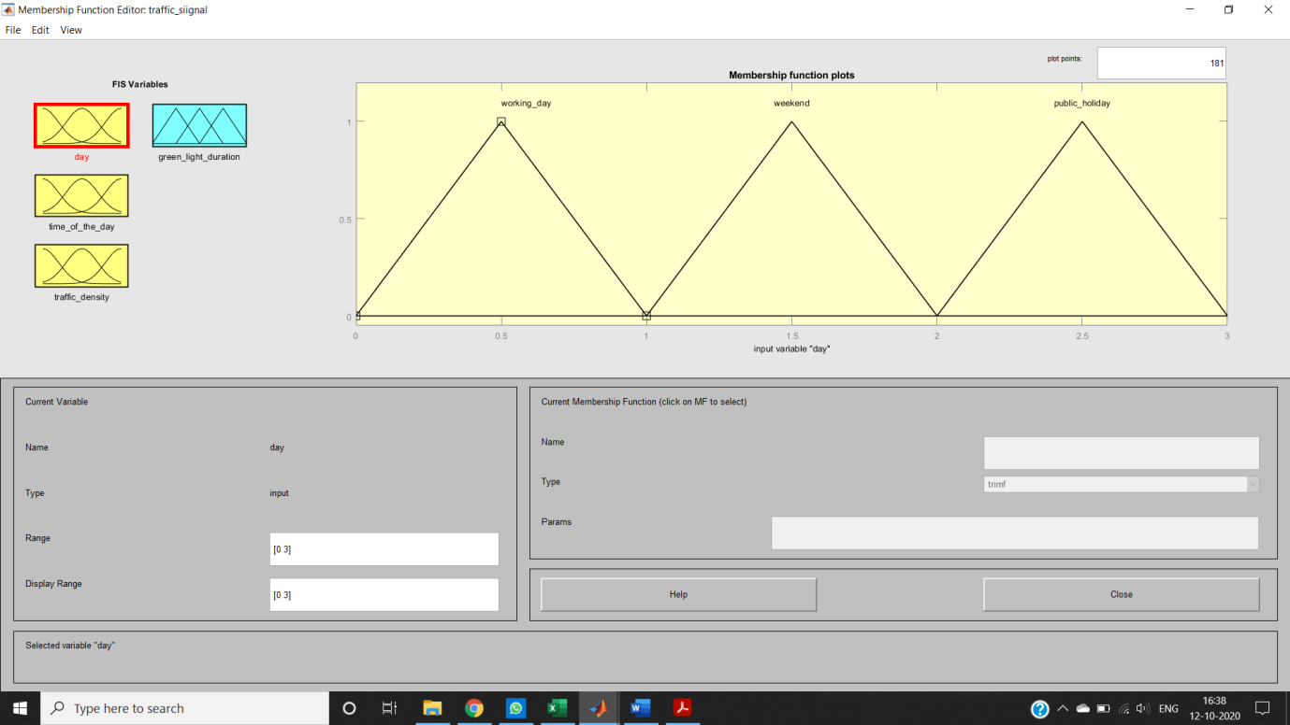

Figure 2: Membership Function –Day

The figure 3 shows the membership function for the input variable Time of the day. The membership function for time of the day are morning= 0 to 5, afternoon= 5 to 10, evening = 10 to 15 and night =15-20

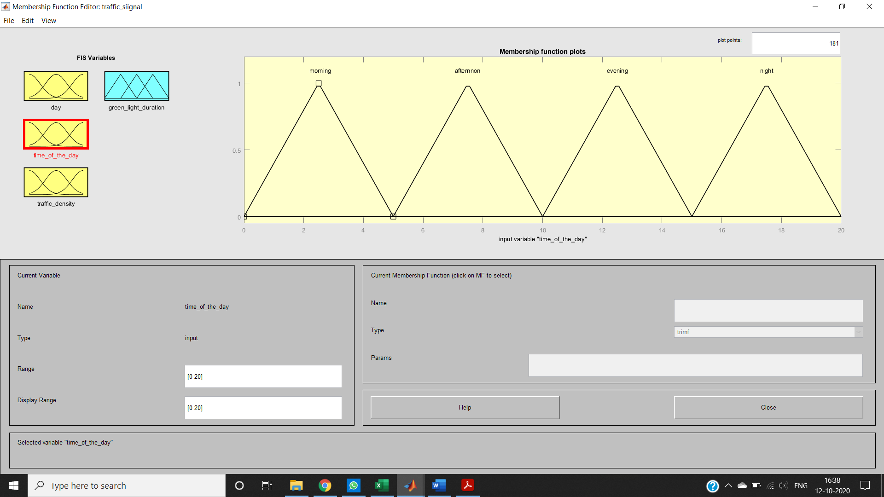

Figure 3: Membership Function –Time of the Day

The figure 4 shows the membership function for the input variable Traffic Density. The membership function for Traffic Density are low= 0 to 15, medium = 15 to 50 and high =50 to 100.

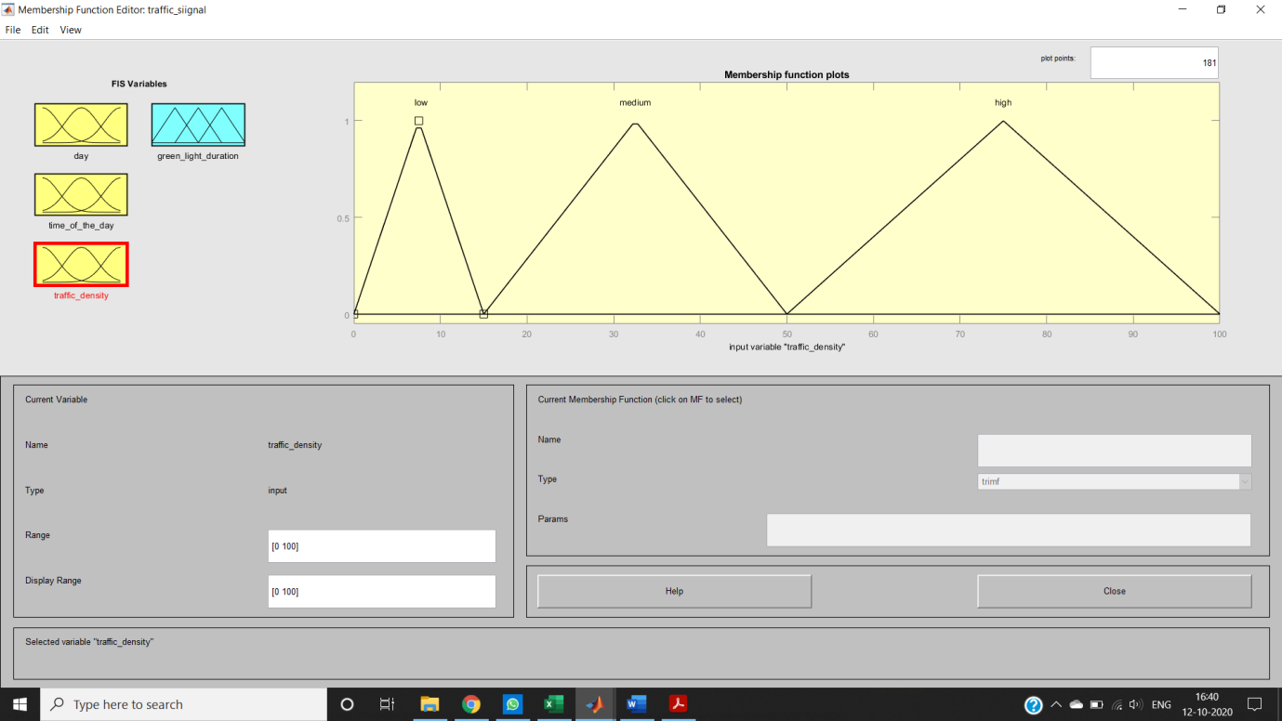

Figure 4: Membership Function- Traffic Density

The figure 5 shows the membership function for the output variable green light duration. The membership function for the green light duration (in seconds) are short = 0 to 10, medium = 10 to 30 and high = 30 to 60.

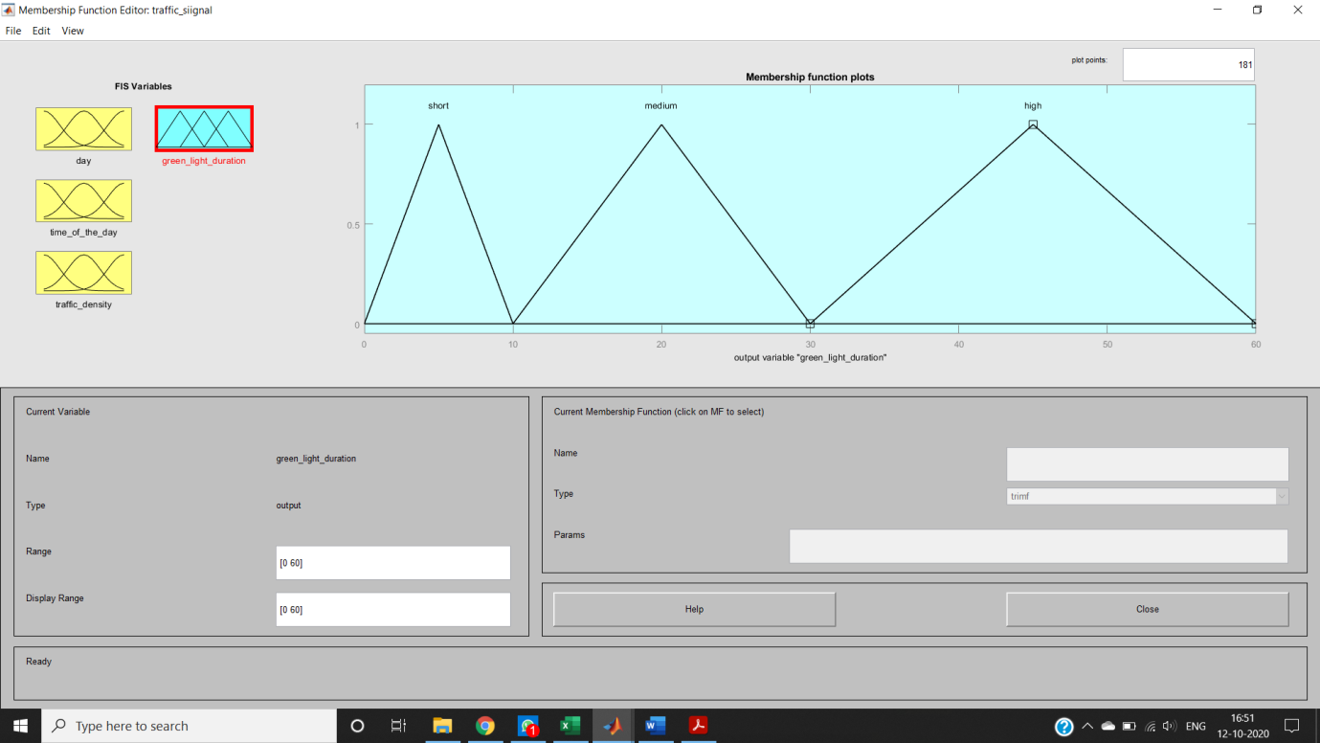

Figure 5: Membership Function - Green light duration

Using FIS editor in MATLAB the proposed fuzzy if-then rules are inserted.

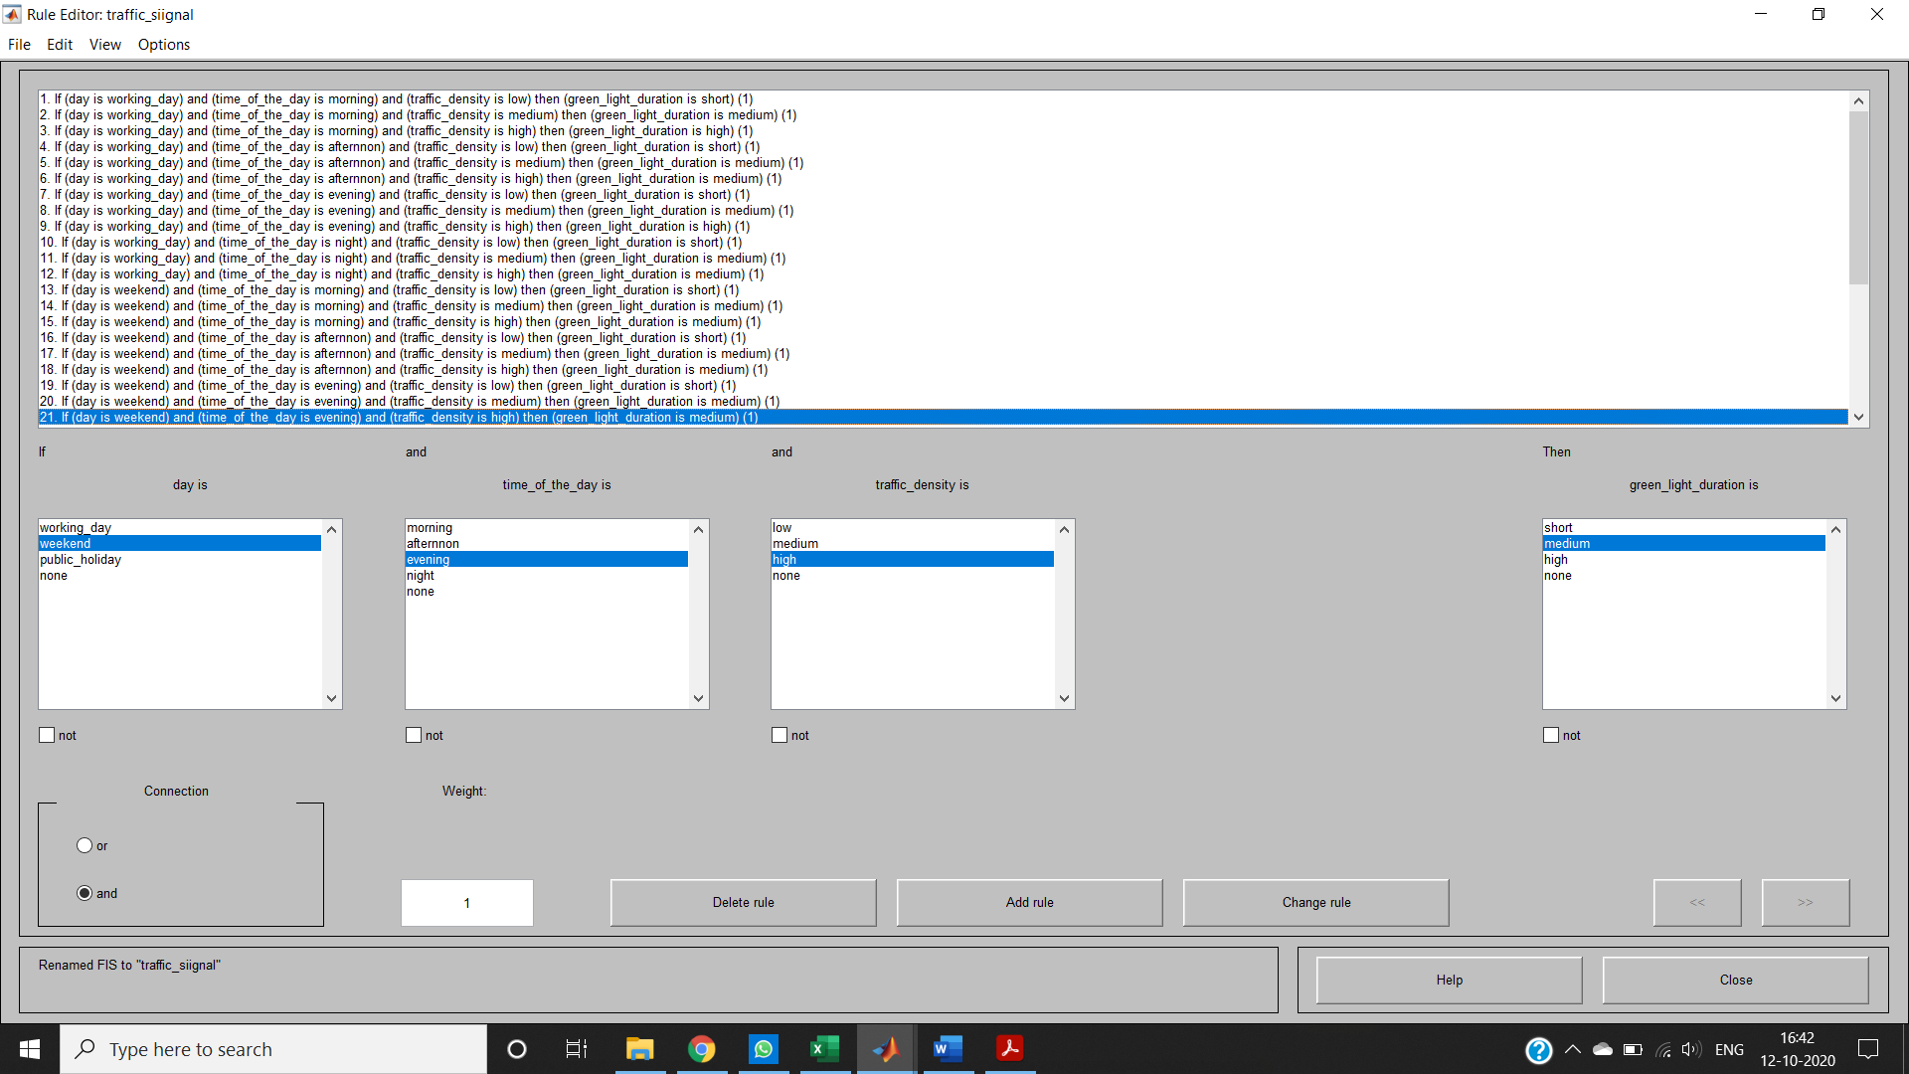

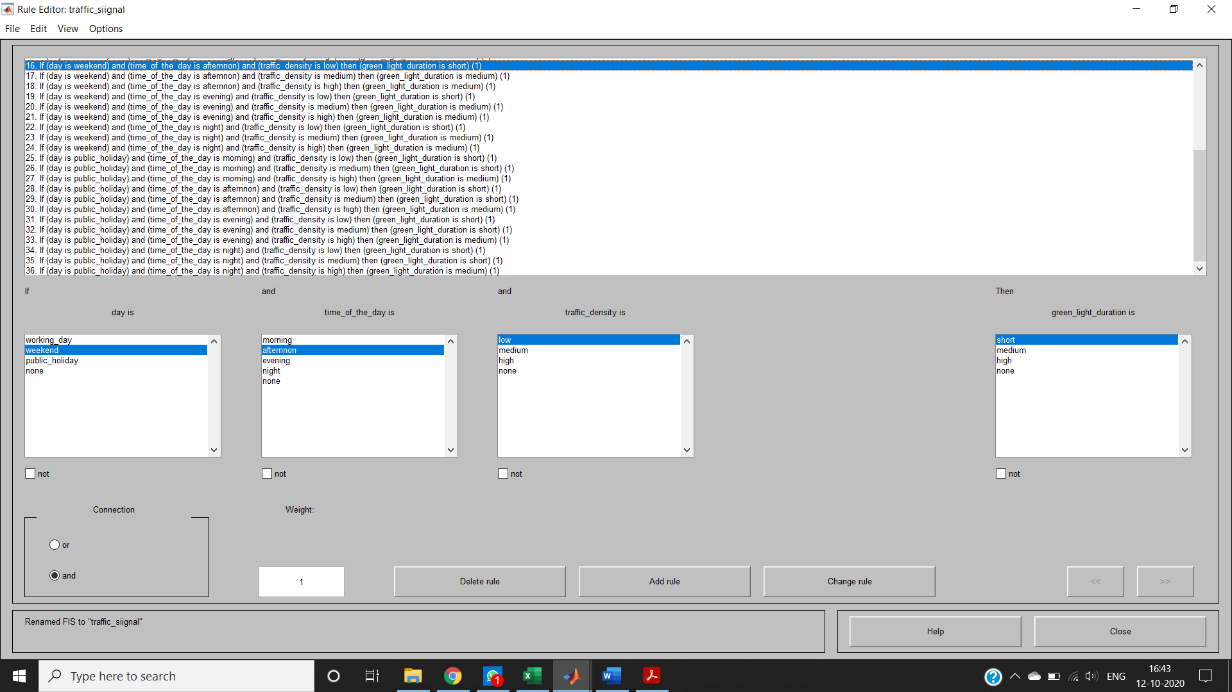

Figure 6: Rule Base

Viewing graphically using rule viewer and surface viewer.

**RULE REPRESENTATION**

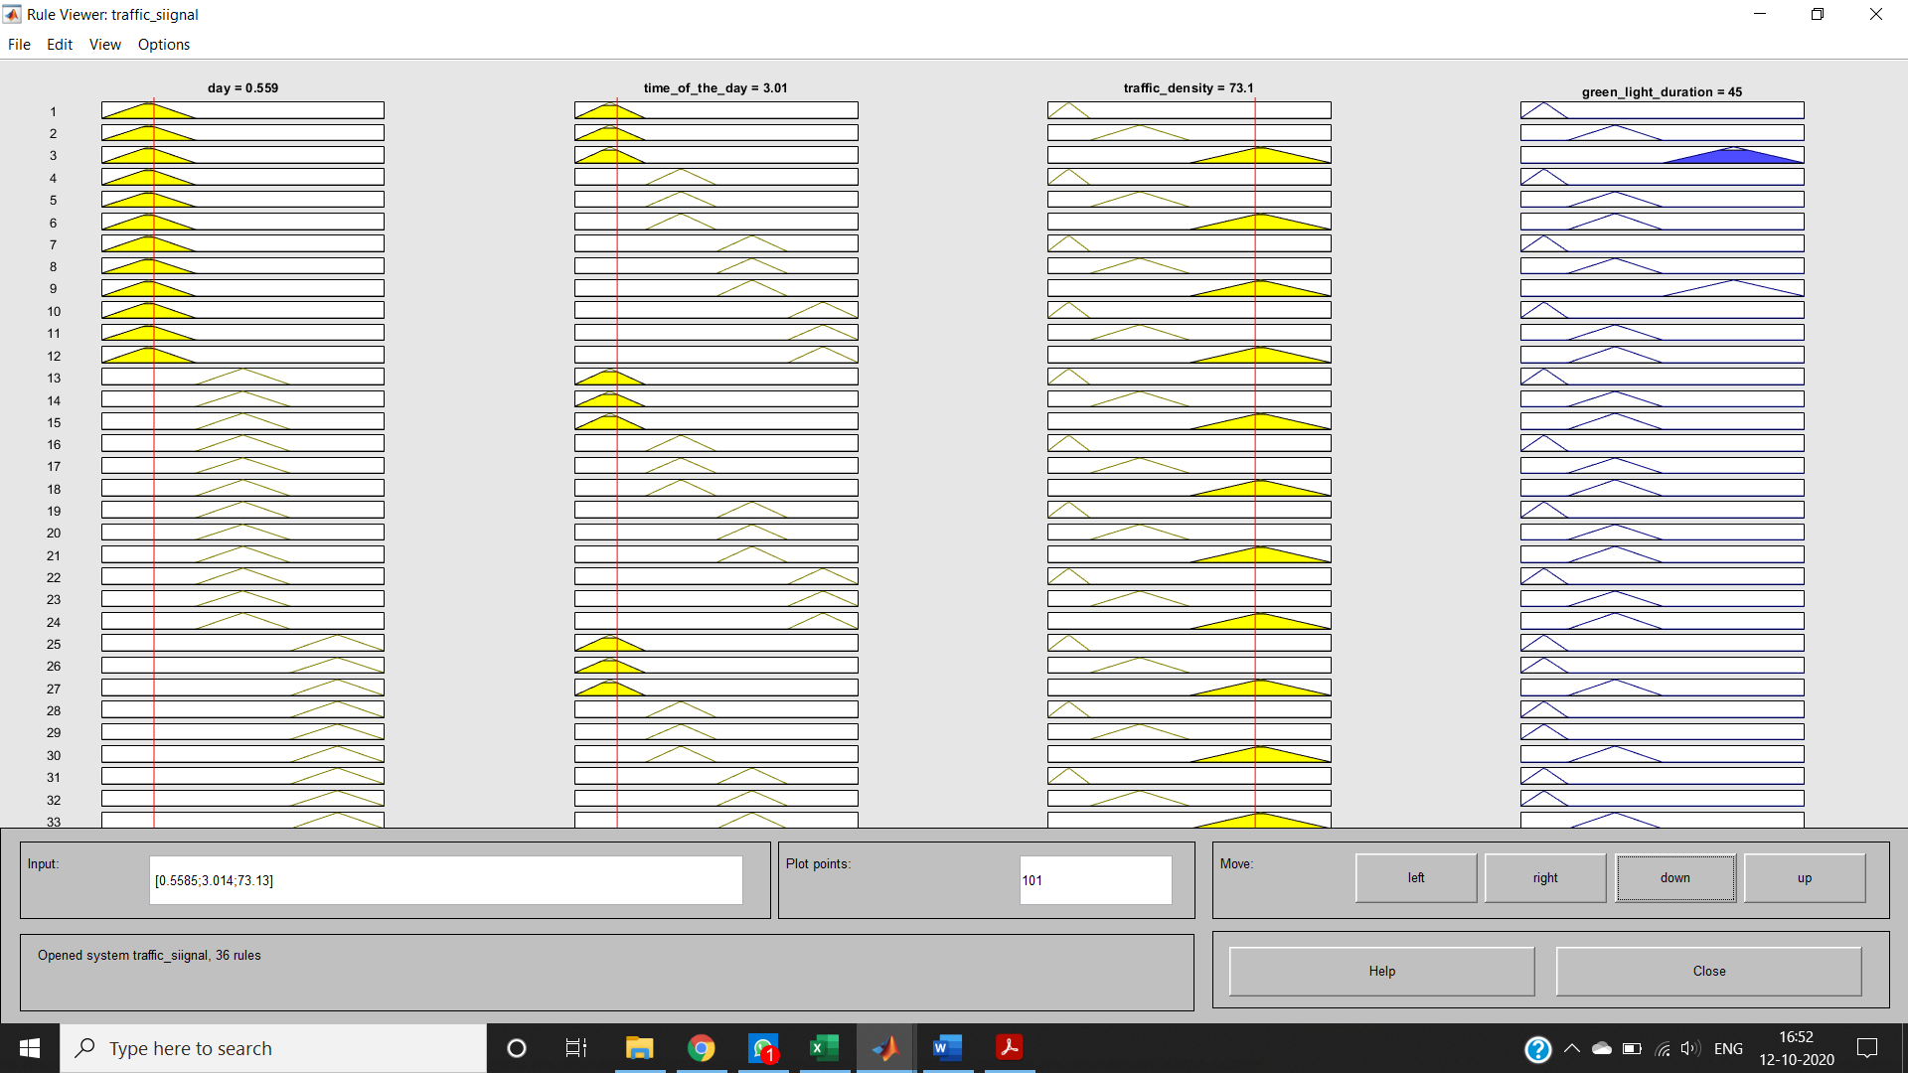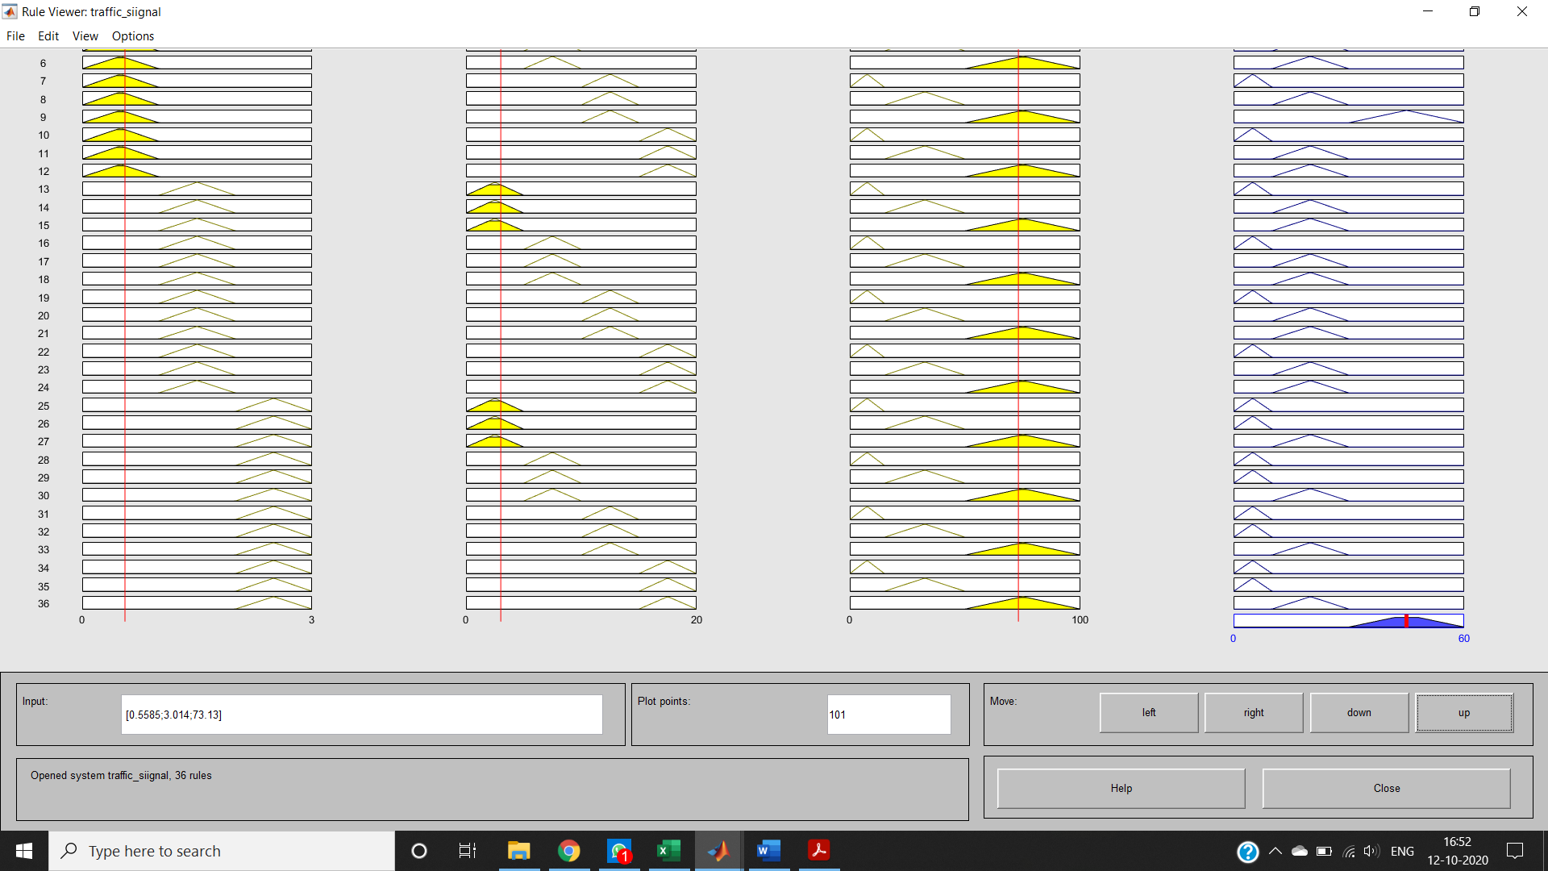

**SURFACE REPRESENTATION**

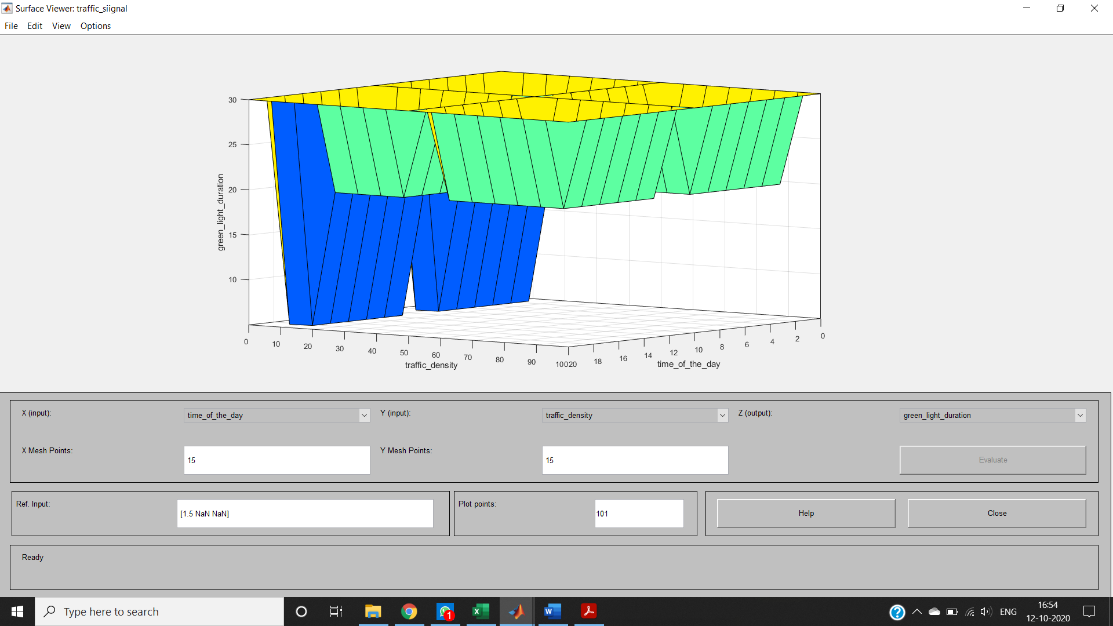

**CONCLUSION**

We were able to develop a fuzzy logic controller to improve the performance of traffic signal controller. The day, traffic density and the time of the day is analyzed for estimating the green light extension time using the fuzzy logic controller.